**Research Fact Sheet/Frequently Asked Questions.**

**Why are we conducting this research?**

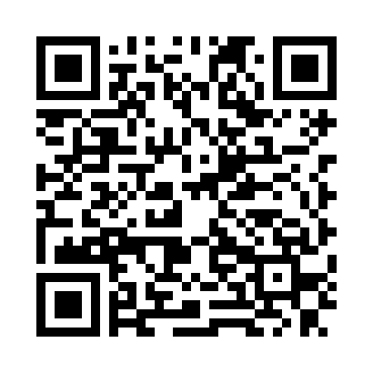Very little is known about how school burnout affects students. We want to know how burnout affects student performance and what might reduce the effects of burnout. By participating, you are helping us understand the student experience of burnout and how it may affect learning.

**Who can participate in this study?**

Any current student at IIT. You can begin by scanning the QR code

**Is this study available on SONA?**

Unfortunately, no. Our project starts before SONA’s opening date and ends after their closing date.

**I decided to participate! What can I expect?**

Excellent! We will be asking you to complete surveys throughout the semester about your feelings of burnout, your confidence in your ability to complete coursework, and a little bit about your personality. We will also ask for you to allow your instructor to share your final percentage grade with us. The first survey starts during the first week of class and must be completed by **Friday, January 20th**. Then, we will send follow up surveys directly to you via email every 3 weeks. The first and last surveys are expected to take 7-10 minutes each, while the ones in between are roughly 5-7 minutes long. Altogether, we expect this to take no more than 1 hour of your time throughout the semester.

**Will my instructor see my responses to the surveys?**

No! All responses are confidential and only the research team will have access to them. Any identifying information will be removed when we prepare research reports.

**Will I receive any payment or course credit for participating?**

Besides the great feeling you get from helping others, there is no compensation for participating in this study. Your instructor may choose to separately give you course or extra credit, which is completely at their discretion.

**My instructor is allowing me to use this as an opportunity for research hours/extra credit. How will you let them know that I participated?**

When the last survey closes, the research team will generate a report and send it to the faculty member you listed in the first survey. In the report, your instructor will only see your name and which of the surveys you completed. No responses will be shared in this report!!

**I still have questions. Who should I reach out to?**

If you still have questions, please direct them to Daniel Gandara at [dgandara@iit.edu](mailto:dgandara@iit.edu) or 713-515-5306, or the principal investigator, Kristina Bauer at [kbauer1@iit.edu](mailto:kbauer1@iit.edu).